Docker Task -2
Create a dockerfile, docker-compose file which when executed must display your basic details in the website.
  - Connect to your Linux server
  - Install Git
# sudo yum update
# sudo yum install git -y
  - Clone your repo from GitHub
# git clone https://github.com/shanthidevim/my-first-git-project.git
  - Create a files in my local
1.4.1 Index.html
<!DOCTYPE html>
<html>
<head>
<title>My first Docker task</title>
</head>
<body>
<h1>Hello 👋</h1>
<h2>My Task Details</h2>
<p><b>Name:</b> Shanthi Devi</p>
<p><b>Role:</b> DevOps Engineer</p>
<p><b>Location:</b> Tamil Nadu, India</p>
<p><b>Skills:</b> AWS, Docker, GitHub</p>
</body>
</html>

1.4.2. dockerfile
FROM nginx:latest

# Remove default nginx page
RUN rm -rf /usr/share/nginx/html/*

# Copy your custom HTML file
COPY index.html /usr/share/nginx/html/

# Expose port
EXPOSE 80

1.4.3. docker-compose.yml
version: '3'

services:
web:
build: .
container_name: my_web_app
ports:
- "8080:80"

  - Push the file to github
# git add.
# git push -u origin
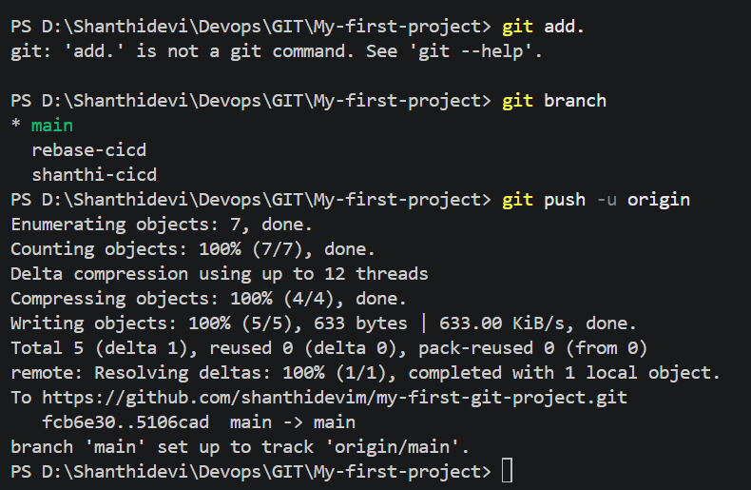
6. Go to your project folder in Linux server
# cd my-first-git-project
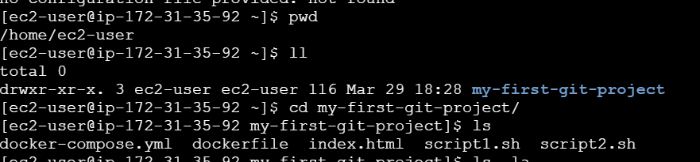
7. Build & run using Docker Compose
# docker-compose up --build -d
8. Install compose File:
# sudo apt update
# sudo apt install docker-compose -y
# docker-compose –version
9. Build & run using Docker Compose
# docker-compose up –build
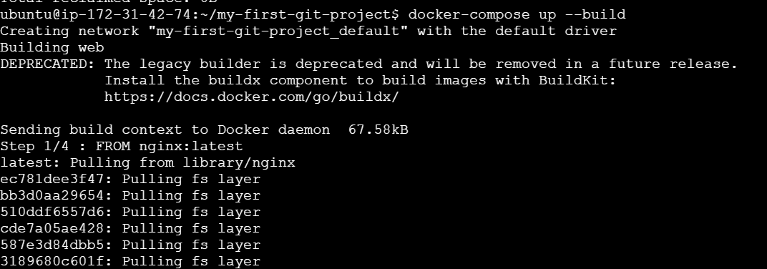
Access Website
http:// 13.206.69.209:8090
